EOI Application No:

SRI LANKA STATE TRADING (GENERAL) CORPORATION LTD.

EXPRESSIONS OF INTEREST
RENTING OF RAJAWASA BATTICALOA BUILDING

EOI NUMBER : STC/ADMIN/RW/BT/01
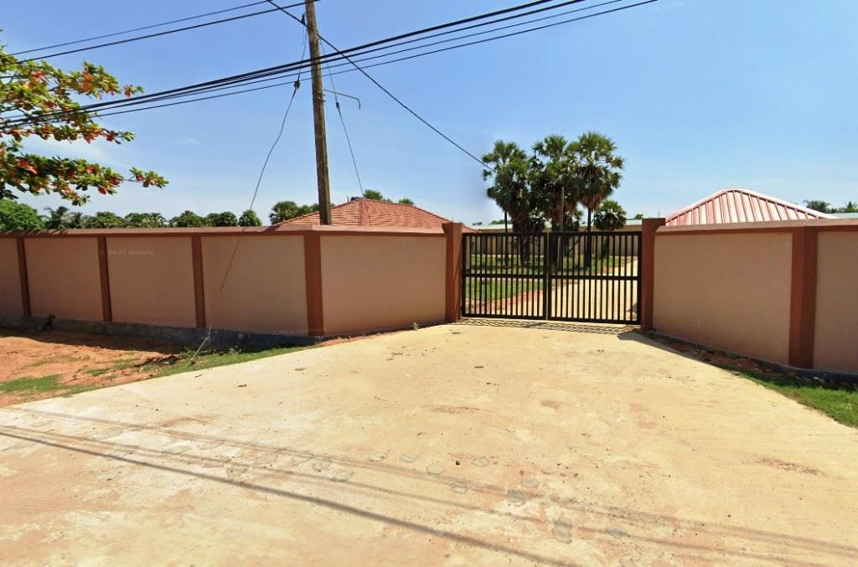

Sri Lanka State Trading (General) Corporation Ltd

No: 100, Nawam Mawatha
Colombo-02

Tel: 011 2422341-4 / 2440880
Fax: 011 2447970

E-mail completed forms to : lankagen@sltnet.lk

EXPRESSIONS OF INTEREST
RENTING OF RAJAWASA BATTICALOA BUILDING
EOI NUMBER: STC/ADMIN/RW/BT/01

APPLICATION FORM FOR ALLOCATION OF SHOP AT “RAJAWASA” SHOPPING COMPLEX BATTICALOA ON LONG TERM RENT BASIS

(Applicants are requested to read the annexed documents prior to filling the application

1. Name of the Applicant / Company

2. National Identity Card / Company Reg: No:
( Attach a copy of Business registration or National ID Card)
3. Permanent Address
4. Postal Address
5. Telephone | Home:
 | Mobile:
 | Office:
6. E-mail
7. Preferred Area in Square Feet ( SQFT)
8. Expected Monthly Rent (Rs.)
9. Proposing Security Deposit
(Minimum 1 Year Rent as Security Deposit)
10. Proposed Use - Type of business and products

(Please explain about your business)

9. DECLARATION OF THE APPLICANT

I/we … of
…………………………………………………………………………………………………… (Address)
the undersigned, having examined the general conditions of the shop/stores and after having fully satisfied myself, do hereby agree to pay the security deposit(9) and 1st monthly rental (8) +VAT for the shop/store within 14 days of the intimation.

I/we also agree to use the premises only for declared purpose of the shop/store allocation.

………………………………………..
Signature of the Applicant
Date……………………….

