Application No:

SRI LANKA STATE TRADING (GENERAL) CORPORATION LTD
Organization functioning under the purview of the Ministry of Trade, Commerce, Food Security and Cooperative Development

EXPRESSIONS OF INTEREST

EOI NUMBER : STC/SS/2025/SH/02

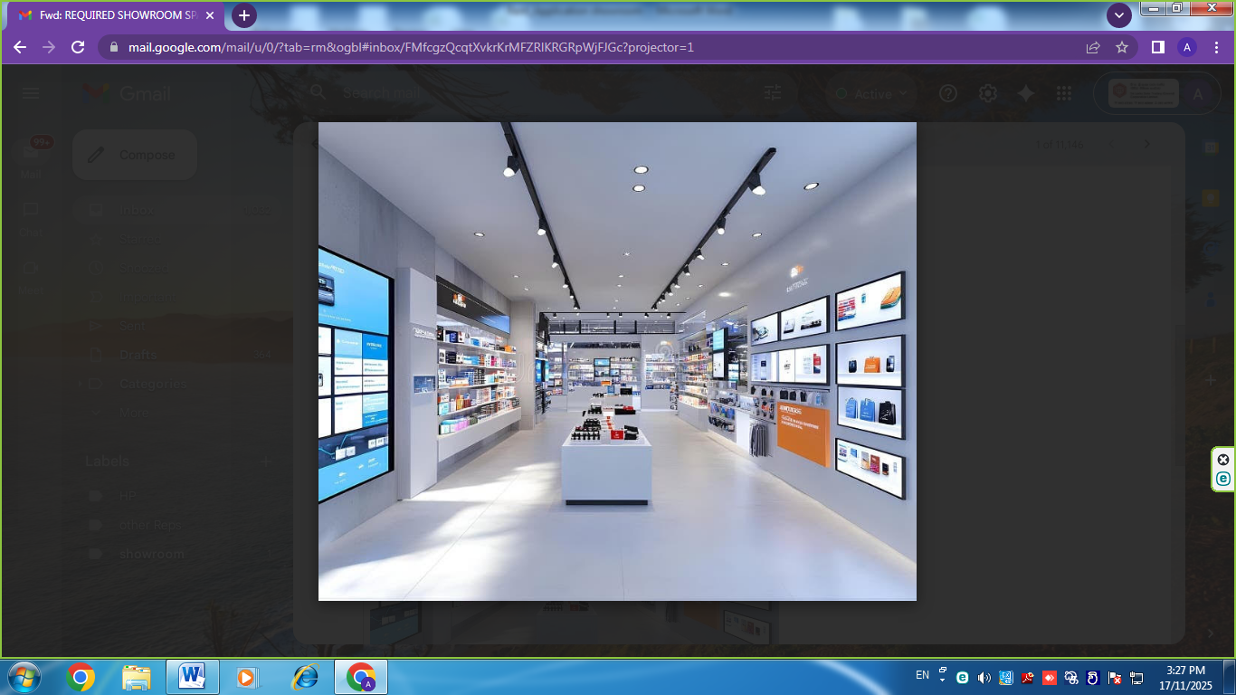
Sri Lanka State Trading (General) Corporation Ltd
No: 100, Nawam Mawatha, Colombo-02
Tel: 011 2422341-4 / 2440880
Fax: 011 2447970
Mobile : 0702590329

Send by register post on or before 05.12.2025 2.00pm and Bid submission fee of Rs.1000 (non-refundable) should be paid to the cashier and receipt should be attached along with the bid.

APPLICATION FORM FOR SHOWROOM SPACE

1. Name of the Applicant / Company
2. National Identity Card / Company Reg: No:
3. Permanent Address
4. Postal Address
5. Telephone | Home:
5. Telephone | Mobile:
5. Telephone | Office:
6. E-mail
7. Required Details
- Location Details with Images(Attach images)
- A copy of the Deed (Attach a copy)
- NIC or BR copy of the owner (Attach
a copy)
- Area of the Showroom (Sq Ft)
- Area of the Land (Perches)
- Available facilities
(Water, Electricity, Washrooms)
- Expected Monthly Rental
- Expected Security Deposit
8. Special Conditions
9. Applicant Signature and Date

